Sports Nutritionist
Certification Seminar

Hosted by

(your name)

Sponsored by IFA with Sports Nutritionists
certified worldwide in over 90 countries.

Certification includes:



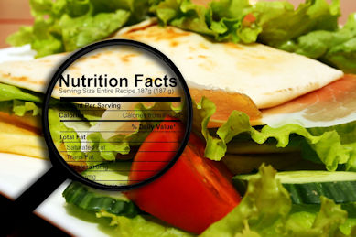

Sports Nutrition

Skills

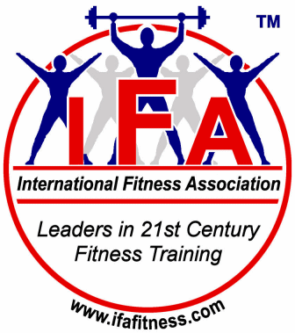
Date: | (seminar date)
Time: | (seminar time)
Place: | (seminar location)
Cost: | (cost for seminar + certification)
Register: | (phone or email)

